

Need help feeding the family during
school holidays?

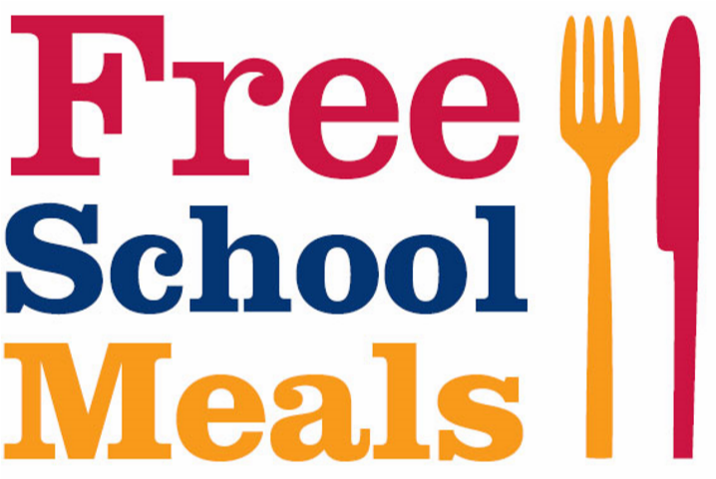
When one or more of
your children receive
free school meals
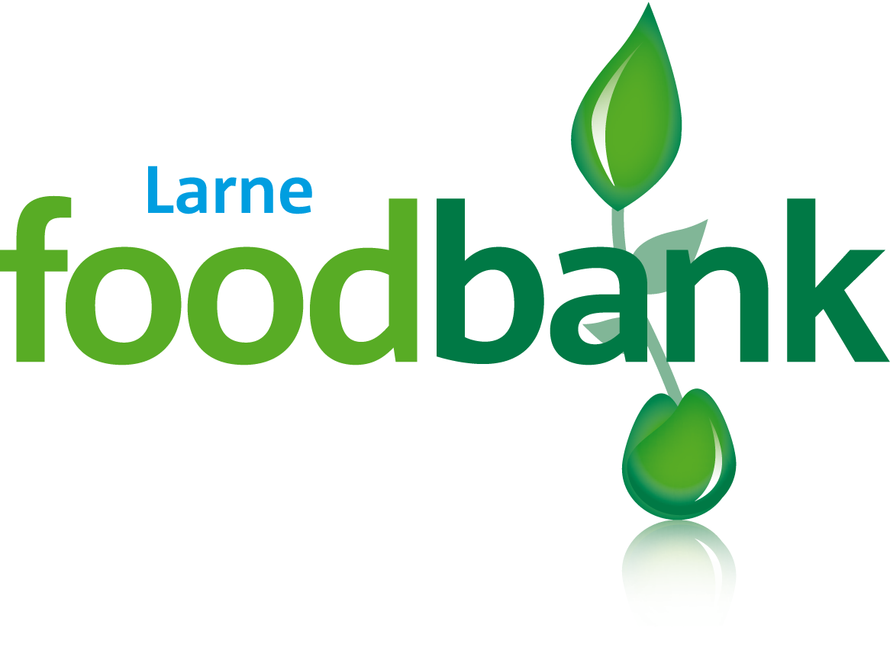

can help

Obtain a red voucher from

(MEACAS)Community Advice Services,

Salvation Army, St Vincent de Paul, Women’s Aid,

CAP, your doctor’s surgery or social worker
and the Foodbank will provide food
for the whole family for three days

Larne foodbank is run in partnership with local churches facilitated by Craigyhill Methodist Church Registered charity number: NIC100087
T: 028 28277530 E: info@larne.foodbank.org.uk www.larne.foodbank.org.uk

